

EY Spark AskMe

Deployment Guide to migrate application from V1 to V3

REVISION HISTORY

|  |  |  |  |
| --- | --- | --- | --- |
| Version | Date | Update | Updated By |
| 0.1 | 2/4/2020 | Draft Version | Subba Reddi Tummuru |

Contents

1. OVERVIEW 3

2. Deployment steps to migrate application from V1 to V3: 3

Step 1: Deploy to your Azure subscription: 3

Step 2: Create deployment slots for app services (bot/configurator). 4

Step 3: Download the publish profile of created slot for both (bot & configurator app) and deploy FAQ Plus V3 code using Visual Studio. 5

Step 4: Add App registration for Tab authentication. 5

Step 5: Update app service Configuration 9

Step 6: Install/Update FAQ Plus V1 manifest file as per the FAQ Plus V3. 10

1. OVERVIEW

The FAQ Plus bot has been deployed in the EY tenant named AskMe. Due to the large volume of tickets it became difficult for the team of 11 experts to manage all the questions in a channel environment. In addition, they would like to find out how many users are asking questions before asking the experts directly. For this reason a tab interface is provided in the Experts Team to provide a tabular view to handling tickets

New functionalities implemented in FAQ Plus application by integrating V2. To deploy the same V3 application, follow below steps.

# 2. Deployment steps to migrate application from V1 to V3:

### Step 1: Deploy to your Azure subscription:

1. Login to Azure portal and search for “Templates”. Templates page will be shown. Click on “+ Add”. Following page will be shown. Enter Name, Description and Click on “Ok”.

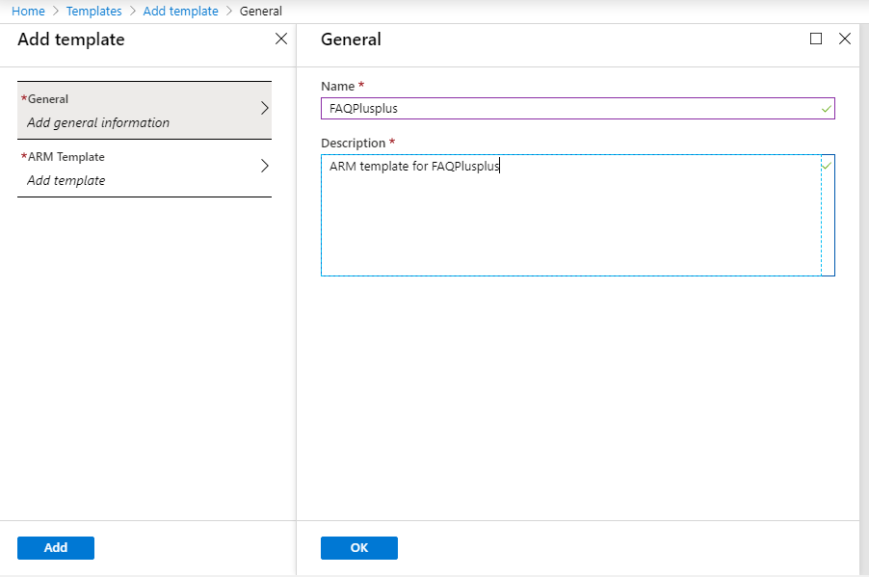

1. Click on “ARM Template” in left navigation.
2. Copy the content of “migration-azuredeploy.json” file in Deployment folder and paste it in ARM template text area. Click on “Ok” to proceed.
3. Click on “Add” to save the template details.
4. Click “Refresh” to see the created ARM template.
5. Click on ARM template name and click on “Deploy”.

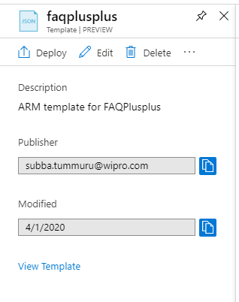

1. Fill the form as shown below:
   * Select existing subscription and resource group where FAQ Plus V1 code has been deployed.
   * Enter a "Base Resource Name", which should be the same as created for FAQ Plus V1.
   * Tenant ID: if your Azure subscription is in a different tenant than your Teams app, please change the tenantID field to the tenant in which you are deploying this Teams app. should be same as V1.
   * Agree to the Azure terms and conditions by clicking on the check box "I agree to the terms and conditions stated above" located at the bottom of the page.
   * Click on "Purchase" to start the deployment.
   * Wait for the deployment to finish. You can check the progress of the deployment from the "Notifications" pane of the Azure Portal. It can take more than 10 minutes for the deployment to finish.
   * Wait for the deployment to finish successfully.
2. Once deployed successfully, go to next step.

### Step 2: Create deployment slots for app services (bot/configurator).

1. Go to azure portal (Azure Subscription where FAQ Plus resources are created) & deployment slots section of app service.
2. Click on Add slot button & provide name, from clone settings from: select settings of existing created resource.
3. Go to your configuration section of new slot and add 3 configuration values (or missing configuration values only for bot app service which were not present in FAQ Plus and need it in FAQ Plus [Version 3]).

{

"name": "ApplicationInsightsLogLevel",

"value": "Information",

"slotSetting": false

},

{

"name": "QnAMakerApiEndpointUrl",

"value": "https://westus.api.cognitive.microsoft.com",

"slotSetting": false

},

{

"name": "QnAMakerSubscriptionKey",

"value": "5b2eca29bf16404dacc5a3517bdc0cc2", // Get this value from Cognitive Service (Go to cognitive service which has created after ARM deployment => Quick start section) copy Key1 value.

"slotSetting": false

},

1. Repeat the above steps for configurator app.

### Step 3: Download the publish profile of created slot for both (bot & configurator app) and deploy FAQ Plus V3 code using Visual Studio.

1. Go to [Azure Portal] (https://portal.azure.com ).
2. Navigate to new slot and download the publish profile.
3. Download the Source code and open solution with Visual studio.
4. Build your solution and right click on project (Microsoft.Teams.Apps.FAQPlusPlus) and select publish code.
5. It will open the window to browse the publish profile.
6. Select the file & click on publish button.
7. It will start deploying the code.
8. After successful deployment, go to your app service deployment slot and swap your slot via clicking on swap button.
9. It will start swapping the code and will point FAQ Plus V3 deployed code.
10. Repeat the same steps for configurator app.

### Step 4: Add App registration for Tab authentication.

1. Log in to the [Azure Portal](https://portal.azure.com/) for your subscription where you have Office 365 tenant, and search with "App registrations" in the search bar. It will redirect to the "App registrations" service.
2. Click on "New registration" to create an Azure AD application.

* Name: The name of your Teams app
* Supported account types: Select "Accounts in this organizational directory only".
* Leave the "Redirect URI" field blank for now.

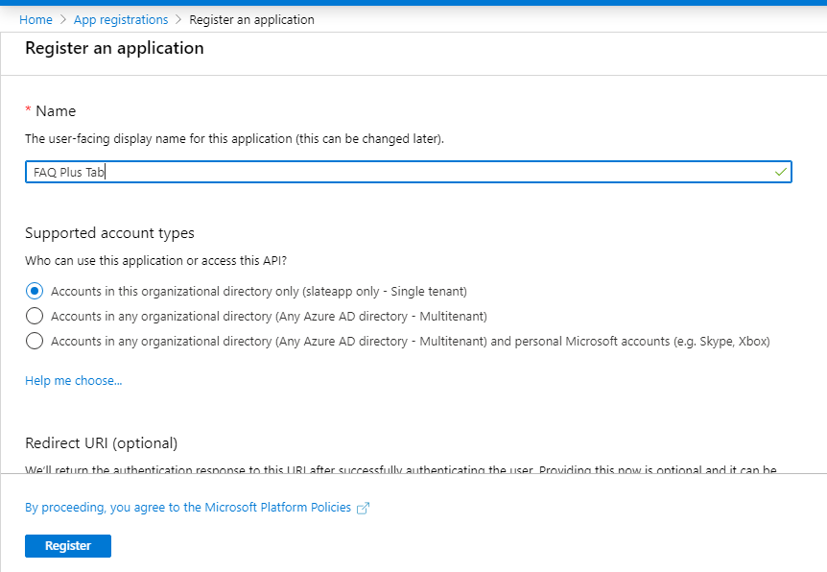

1. Click on the "Register" button.
2. When the app is registered, you'll be taken to the app's "Overview" page. Copy the Application (client) ID, Directory (tenant) ID; we will need it later. Verify that the "Supported account types" is set to “My organization only”.

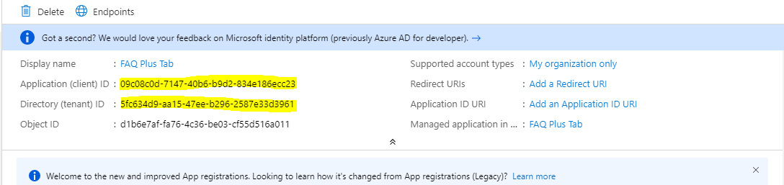

1. On the side rail in the “Manage” section, Click on "Certificates & secrets" link. In the “Client secrets” section, click on "+ New client secret". Add a description for the secret and choose “Never” in Expires field. Click on "Add".

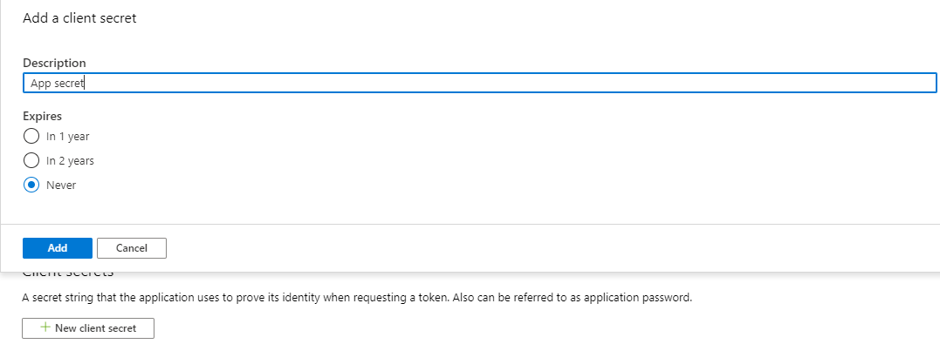

1. Once the client secret is created, copy it’s Value; we will need it later.
2. Under "Manage", click on "Authentication" to bring up authentication settings.
3. Click on “+Add Platform”, and then click on “Web”. Add two entries to "Redirect URIs":

* Type: Web
* Redirect URI: Enter "https://<<appDomain>>/signin-simple-end" and “https://<<appDomain>>/signin-oidc”for in Redirect URL field

1. Under "Implicit grant", check both “Access tokens” and "ID tokens".
2. Select “No” in Default client type.
3. Click "Save" to commit your changes

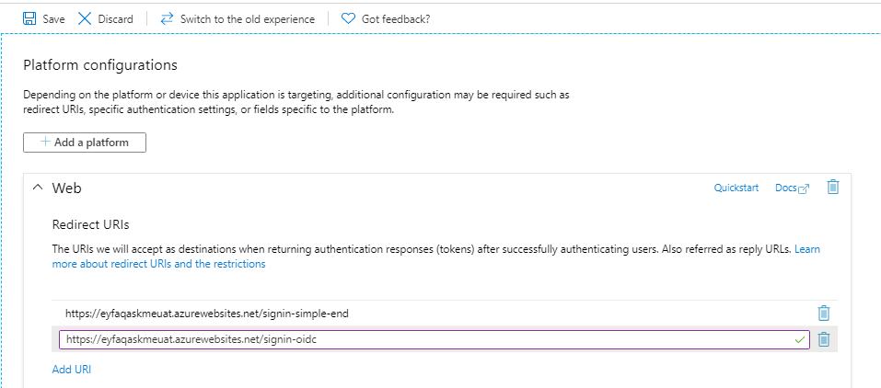

1. Back under "Manage", click on "Expose an API".
2. Click on the "Set" link next to "Application ID URI" and change the value to https://<<appDomain>>
3. Click "Save" to commit your changes.
4. Click on "Add a scope", under "Scopes defined by this API". In the fly out that appears, enter the following values:

* Scope name: user_impersonation
* Who can consent: Admins and users
* Admin and user consent display name: Provide display name
* Admin and user consent description: Enter “Allow the application to access on behalf of the signed-in user”.

1. Leave remaining fields as it is and Click on "Add scope" to commit your changes.
2. To allow application to work in Microsoft Teams Web client, follow below steps:
   * Click on "Add a client application", under "Authorized client applications". In the fly out that appears, enter the following values:
     1. Client ID: Provide the following client id : 5e3ce6c0-2b1f-4285-8d4b-75ee78787346
     2. Authorized scopes: Select the scope that ends with user_impersonation. (There should only be 1 scope in this list.)
   * Click "Add application" to commit your changes.
3. To allow application to work in Microsoft Teams Desktop client, follow below steps:
   * Click on "Add a client application", under "Authorized client applications". In the fly out that appears, enter the following values:
     1. Client ID: Provide the following client id : 1fec8e78-bce4-4aaf-ab1b-5451cc387264
     2. Authorized scopes: Select the scope that ends with user_impersonation. (There should only be 1 scope in this list.)
   * Click "Add application" to commit your changes.
4. After making above changes, screen will be shown as follows:

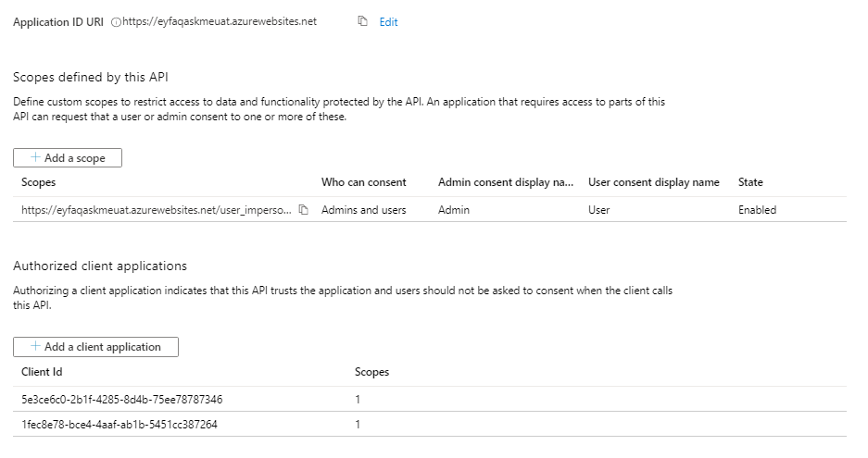

1. Back under "Manage", click on "Manifest".
2. In the editor that appears, find the optionalClaims property in the JSON Azure AD application manifest, and replace it with the following block:

|  |
| --- |
| "optionalClaims": {  "idToken": [],  "accessToken": [  {  "name": "upn",  "source": null,  "essential": false,  "additionalProperties": []  }  ],  "saml2Token": []  }, |

Also verify below properties

|  |
| --- |
| "allowPublicClient": true  "oauth2AllowIdTokenImplicitFlow": true  "oauth2AllowImplicitFlow": true |

1. Click "Save" to commit your changes.

### Step 5: Update app service Configuration

1. Open app service and add the below configuration values. This is not required to add to Config app.
2. Replace Appdomain, Tab_app_registration_Client_id, Tab_app_registration_Client_secret, TenantId with values.

{

"name": "AzureAd:ApplicationIdURI",

"value": "https://<< Appdomain>>",

"slotSetting": false

},

{

"name": "AzureAd:ClientId",

"value": "<<Tab_app_registration_Client_id>>",

"slotSetting": false

},

{

"name": "AzureAd:ClientSecret",

"value": "<<Tab_app_registration_Client_secret>>",

"slotSetting": false

},

{

"name": "AzureAd:GraphScope",

"value": "https://graph.microsoft.com/User.Read.All openid profile",

"slotSetting": false

},

{

"name": "AzureAd:Instance",

"value": "https://login.microsoftonline.com",

"slotSetting": false

},

{

"name": "AzureAd:TenantId",

"value": "<<TenantId>>",

"slotSetting": false

},

{

"name": "AzureAd:ValidIssuers",

"value": "https://login.microsoftonline.com/<<TenantId>>/v2.0,https://sts.windows.net/<<TenantId>>/",

"slotSetting": false

},

### Step 6: Install/Update FAQ Plus V1 manifest file as per the FAQ Plus V3.

1. Download latest manifest file and make updates.
2. Uninstall the existing expert bot and install the latest manifest for FAQ Plus [Version 3]